Location Map and Aerial View of LGS 1 also known as Hoppitt Field.
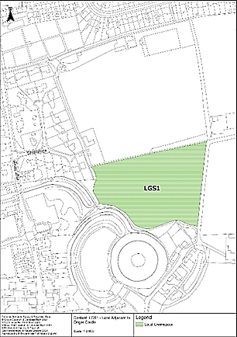 | 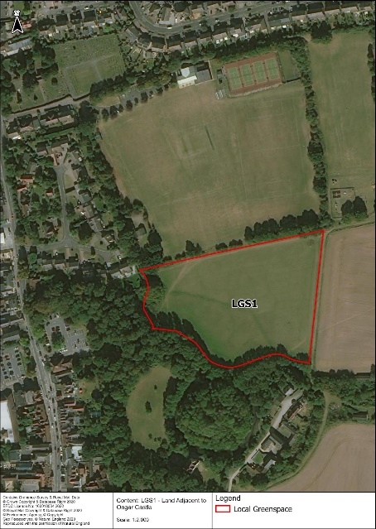
Location Map | Aerial View from Google Earth

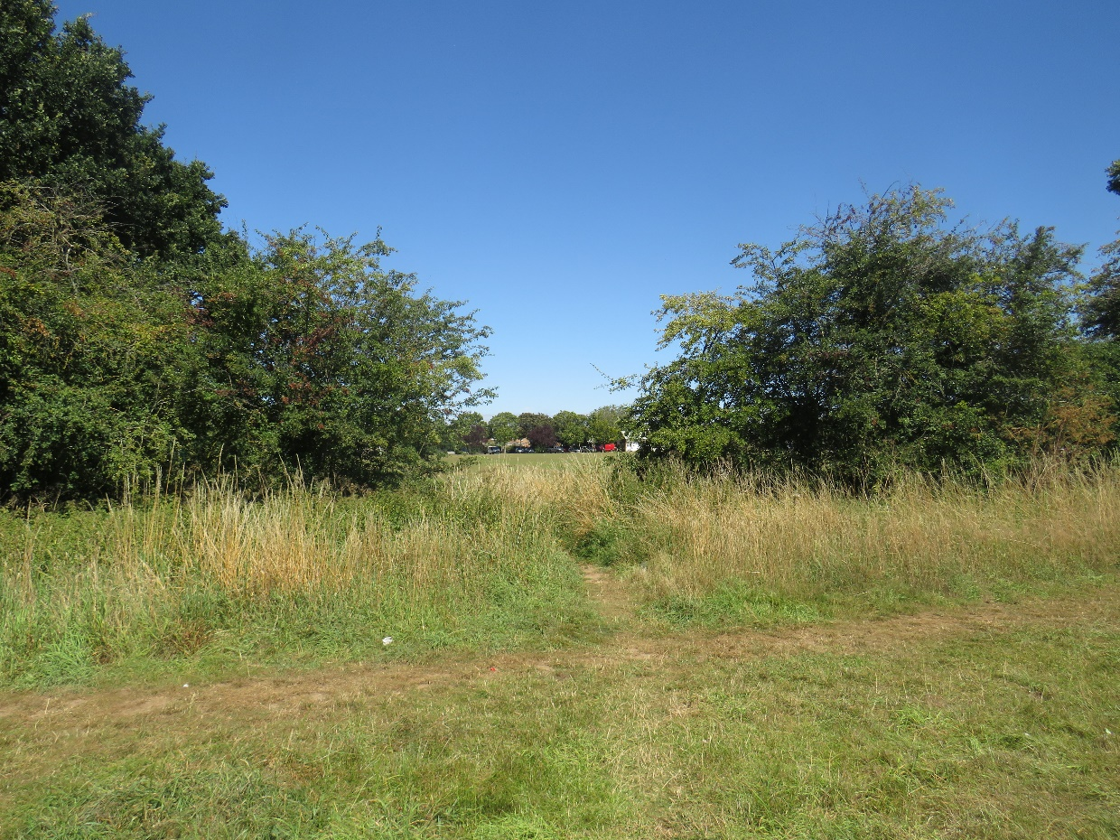
Connectivity between Hoppitt Field and Love Lane Sports Field
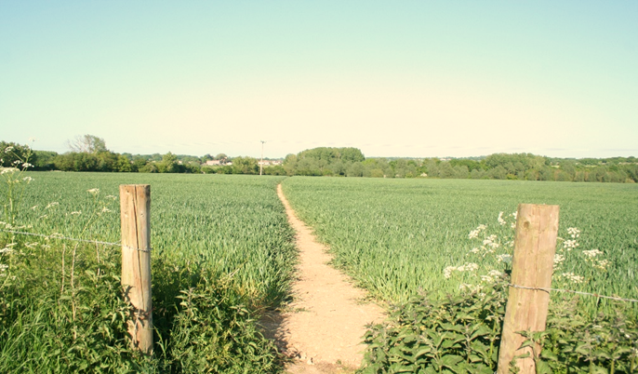 | 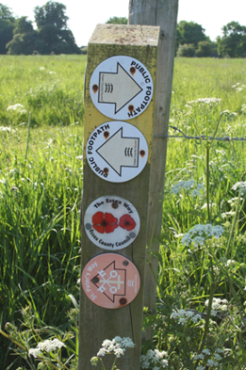
St Peter’s Way, a long-distance footpath to High Ongar and beyond | Assorted signs posts on the edge of this field

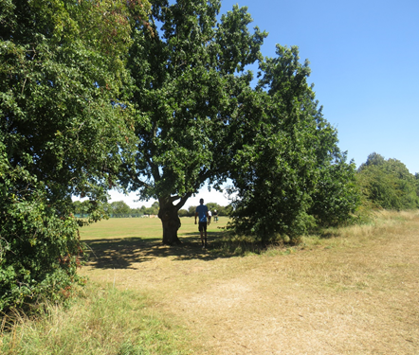 | 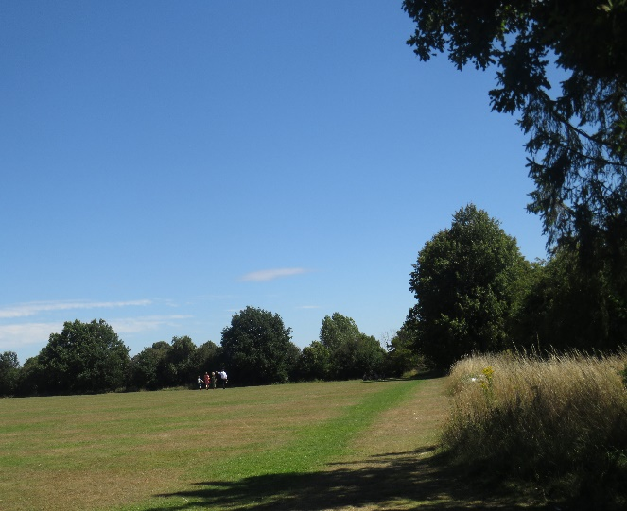
Trees on boundary with Sports Ground | View towards the trees round the Castle

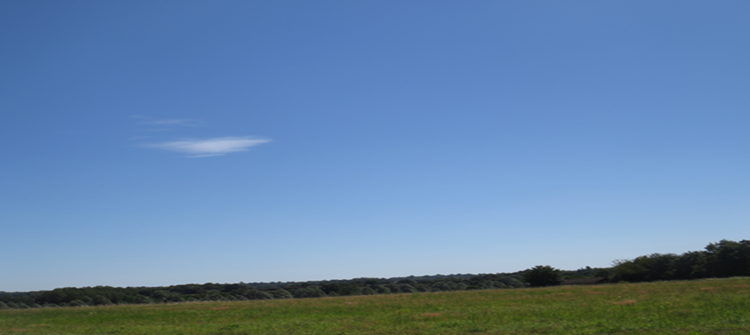
The uplifting open sky above the wooded Roding Valley, a place to feel the wind in your hair and watch buzzards, red kites or rooks show off their aerial acrobatics!

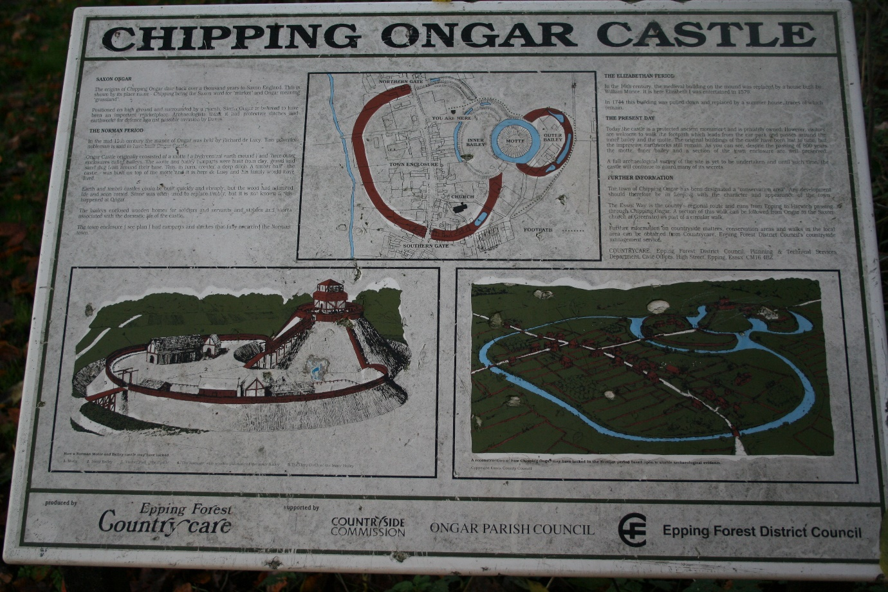
Information board in Pleasance Garden adjacent to Hoppitt Field.

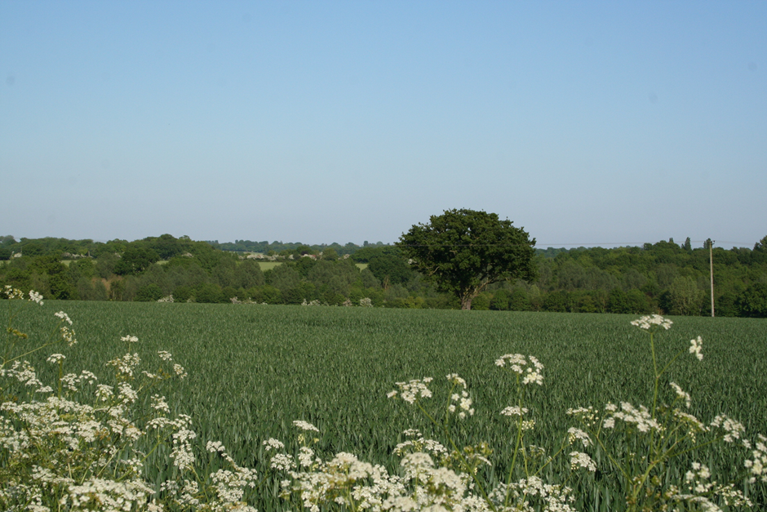
The view of the Roding Valley from the edge of Hoppitt Field.

Location Map of Jubilee LGS 2 and LGS 4 the Jubilee Nature Reserve and Longfield
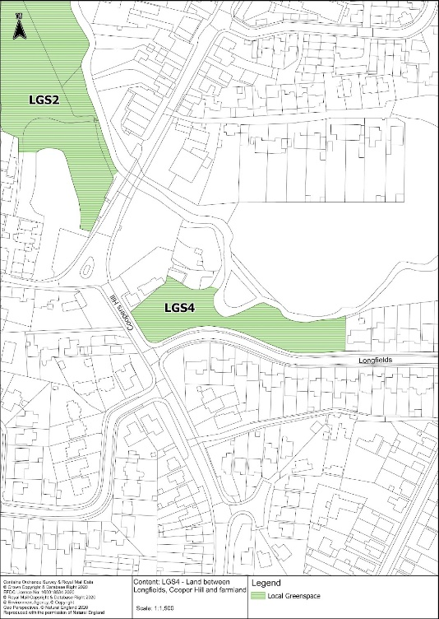 | 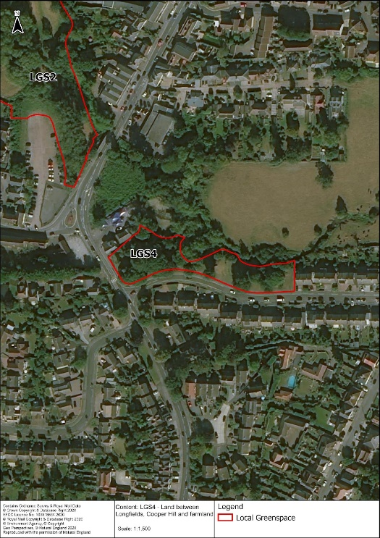
Location map of sites | Aerial view of sites

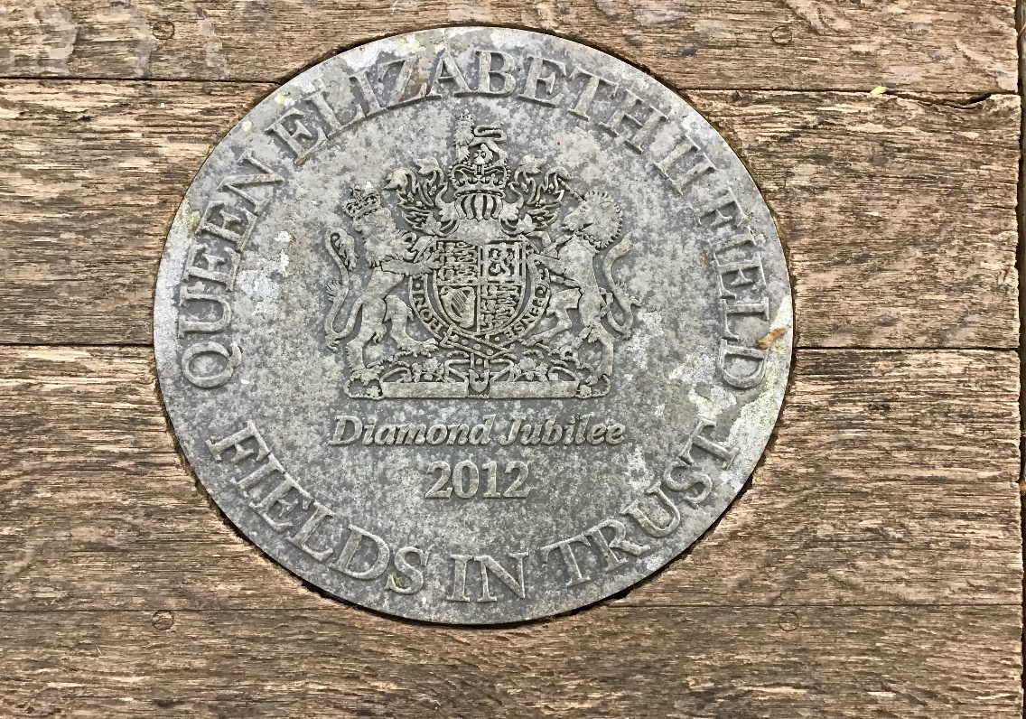
The plaque by the entrance to the Reserve to mark its transfer to Fields in Trust in 2012.

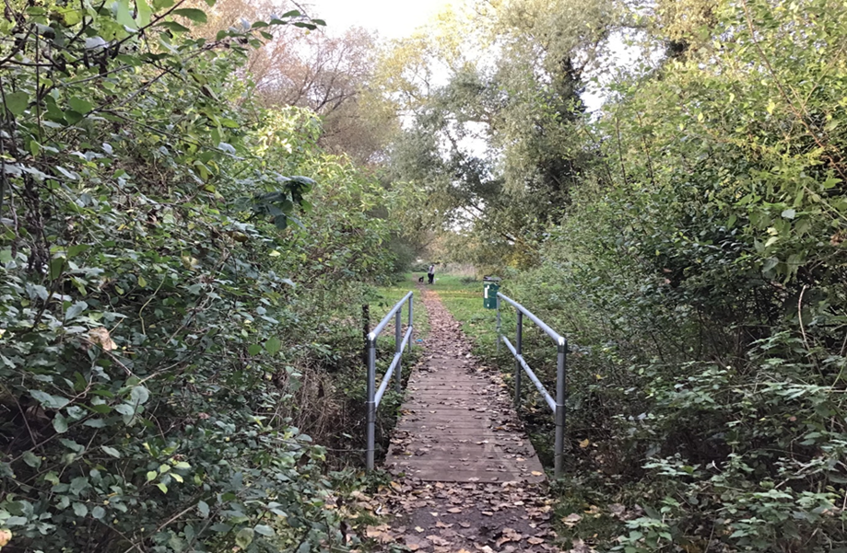
Installed in 2021 a replacement bridge over small stream to keep footpath accessible.

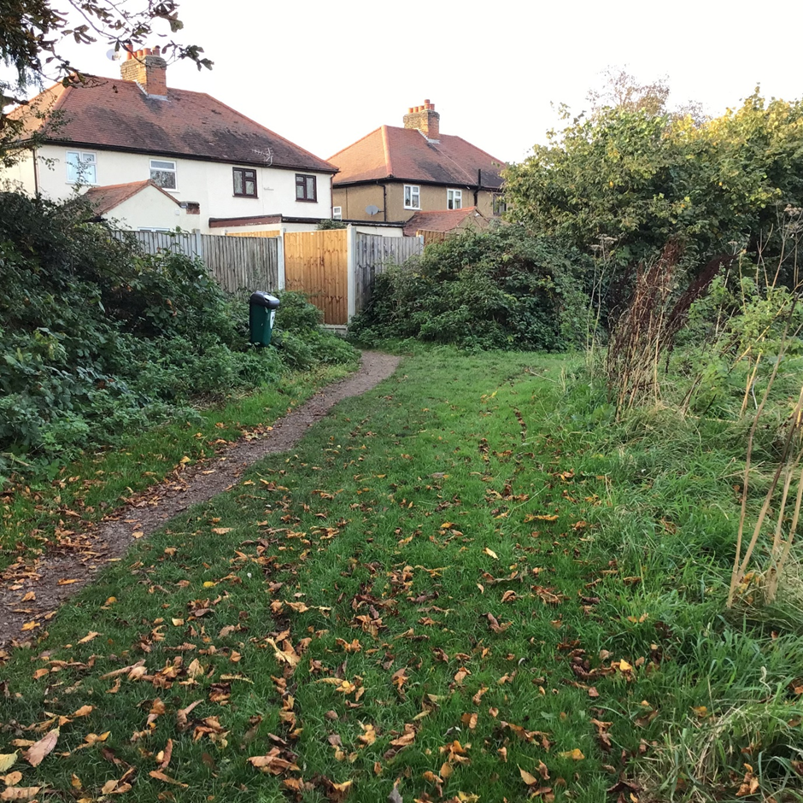
Access to Rodney Road from the Reserve, firm path suitable for buggies.
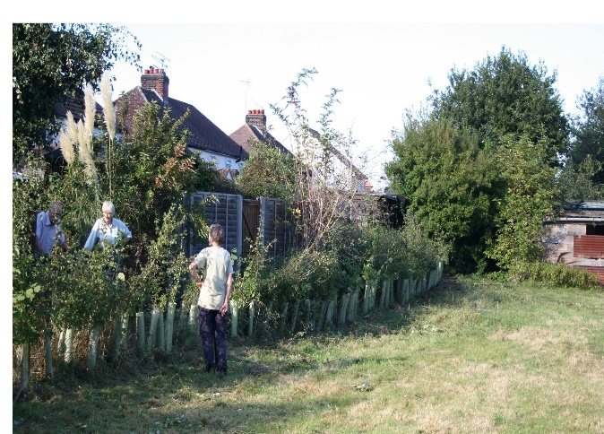 | 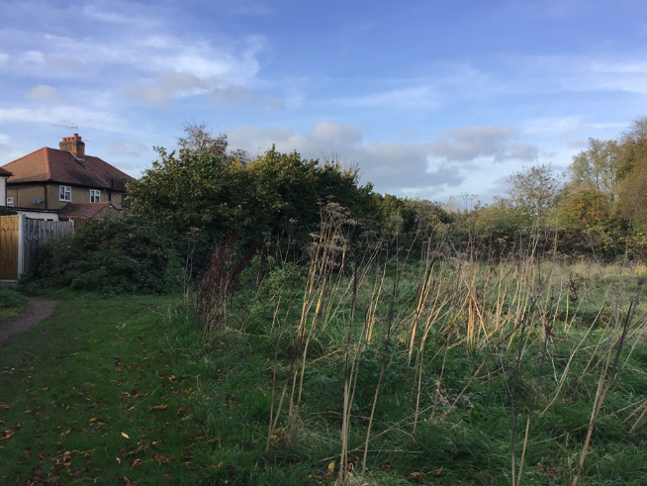
Planting mixed hedge in 2010 | Mature hedgerow in 2021

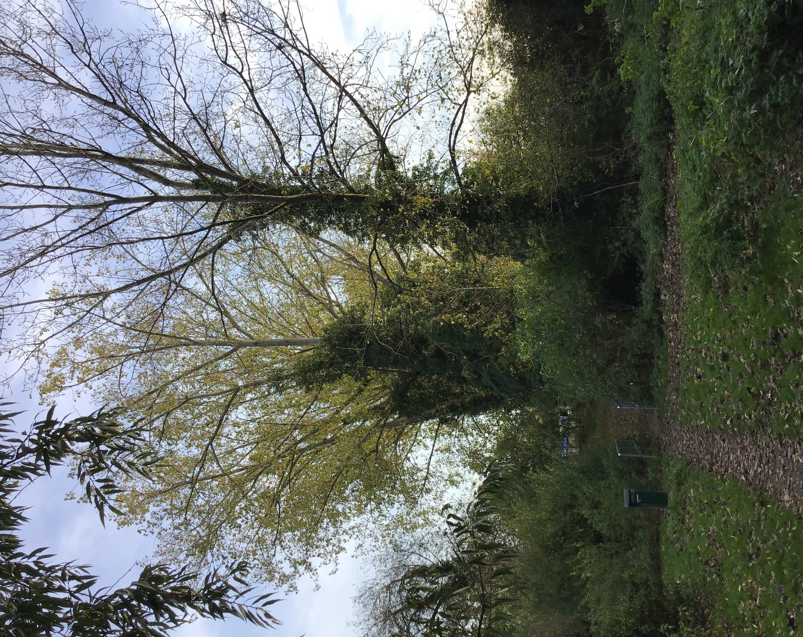
The row of tall poplars alongside the footpath linking Rodney Road with the High Street.

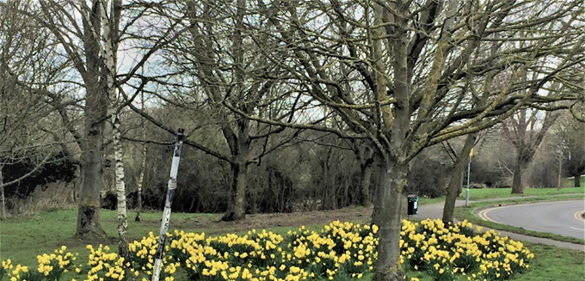
Daffodils on grass verge at Longfields, a spring welcome to
Chipping Ongar

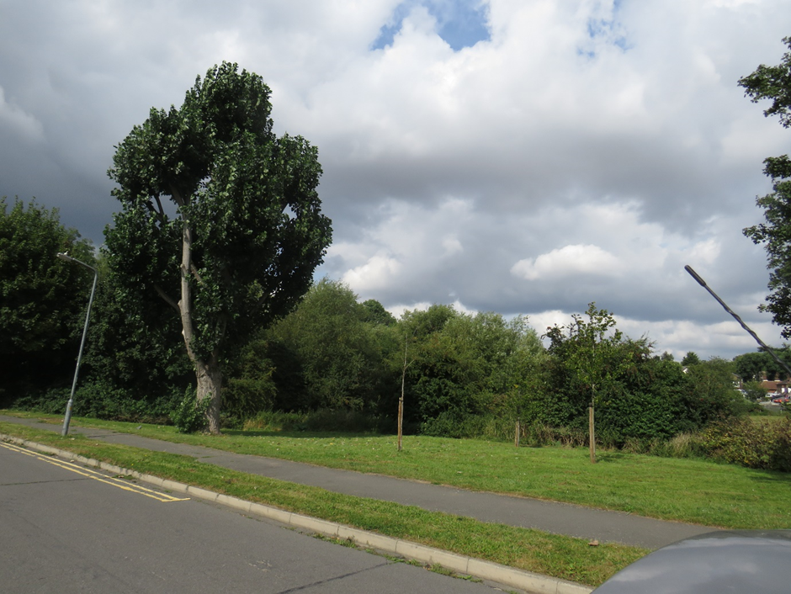
Hybrid poplar tree, and new field maples in the grass opposite Longfields, with distant view of houses on the other side of the Cripsey Brook. Some young field maples have been planted to increase the diversity of species present.

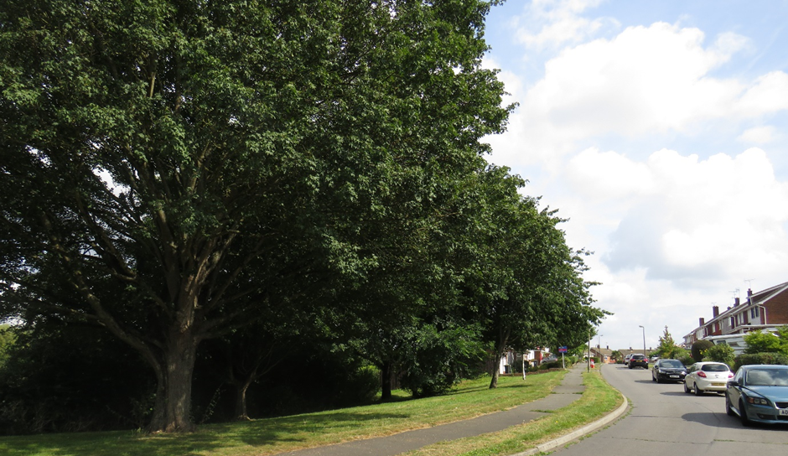
View along Longfield Road with a mixture of planted trees within the grass between the road and the Cripsey Brook.

Location Map and Aerial View LSG 3 also known as Long Meadow
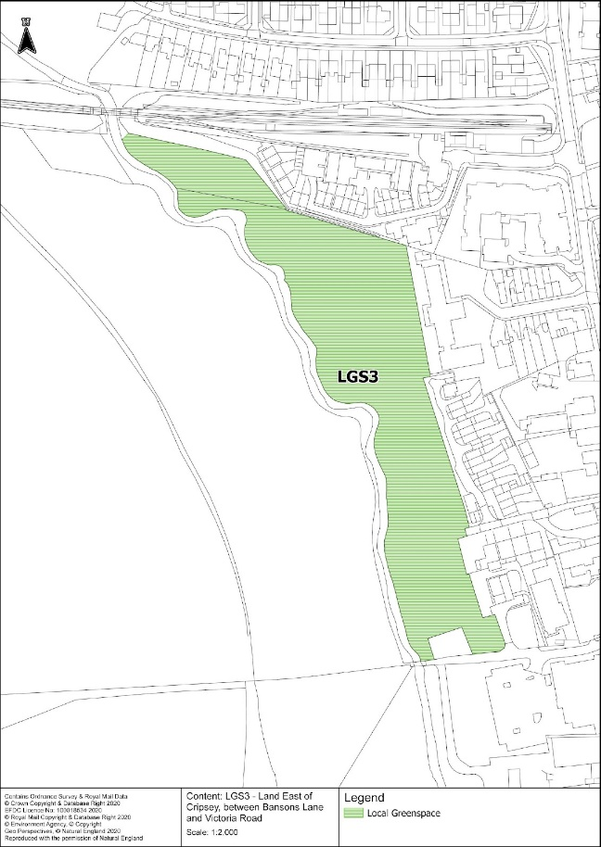 | 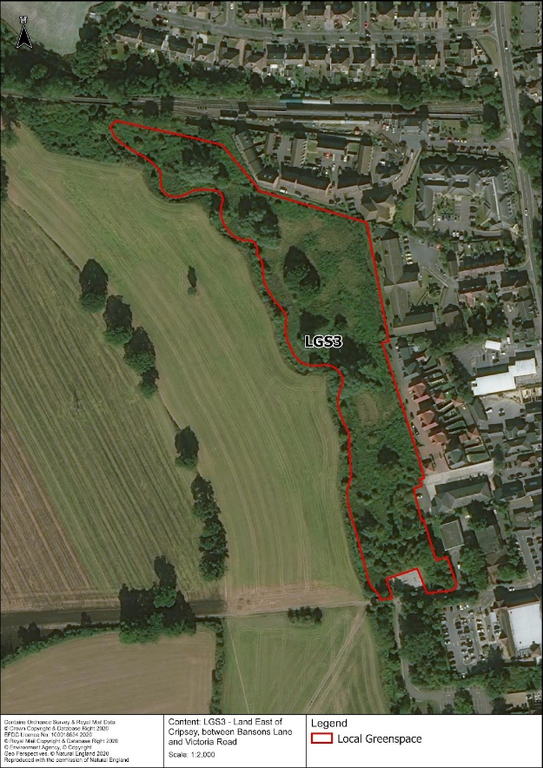
Location map of Long Meadow | Aerial view of Long Meadow

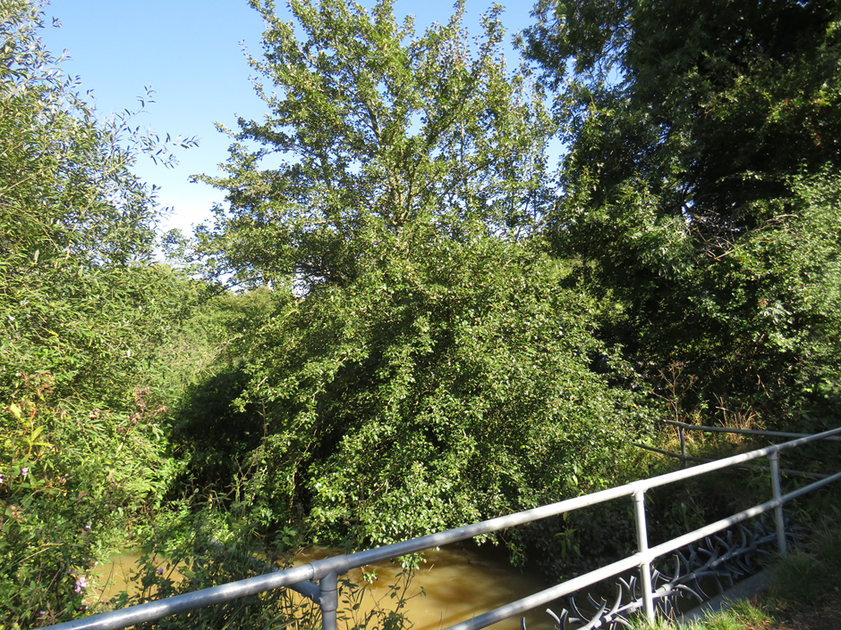
Access point form Banson’s Lane viewed from the bridge over the Cripsey Brook. The tree is a wild pear, a rare species in the District.

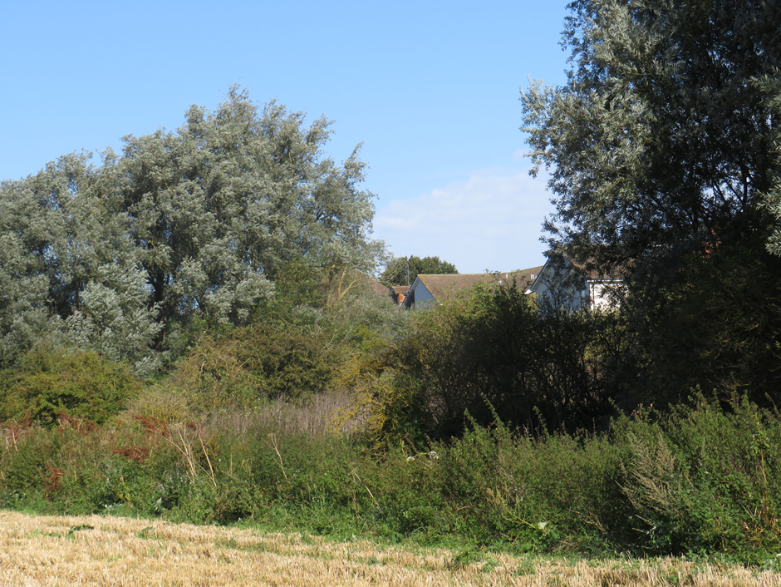
Green space of Long Meadow between the arable land, Cripsey Brook and the new houses to the west of the High Street.

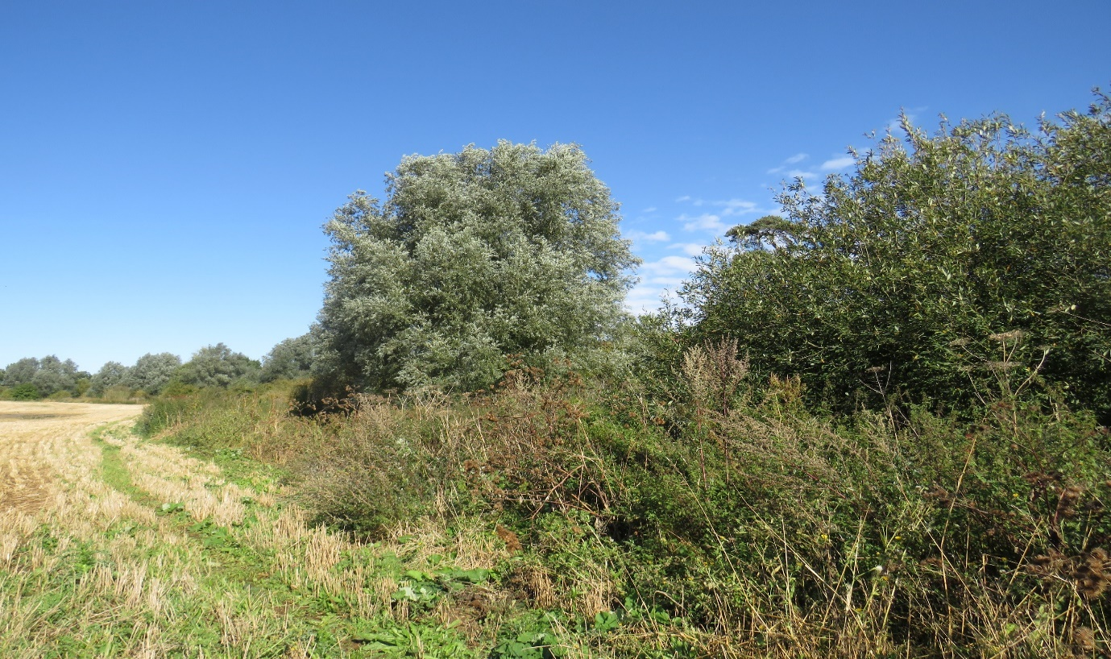
View upstream of the green corridor of the open space of Long Meadow on either bank of the Cripsey Brook. A wonderful habitat for a wide variety of creatures, including various butterflies and moths, several species of bat, small mammals, foxes and badgers. Songbirds such as blackbirds, robins, hedge sparrows, wrens as well as slow worms and grass snakes will thrive in such habitats.

EB706 map PPG17 showing EFDC green spaces for Ongar including SOs and MOs

See next page for Green Corridor links around Chipping Ongar

Ongar Neighbourhood plan Projects and Actions excerpt – Green Corridor map linking various green space and footpaths around Chipping Ongar

