GENERAL DATA PROTECTION REGULATION SUBJECT ACCESS REQUEST

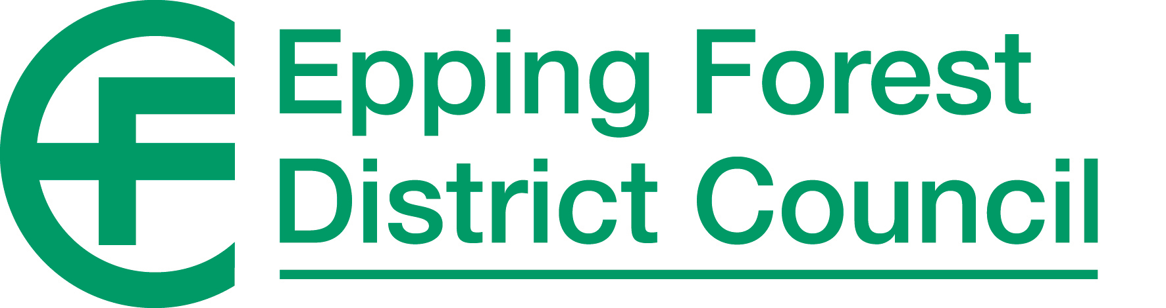

The General Data Protection Regulation (GDPR) provides individuals with a right of access to their personal information, through a Subject Access Request. The Council can only disclose information about the person making the Subject Access Request and will not generally provide information which identifies other people.

To enable a Subject Access Request to be dealt with efficiently, the Council is entitled to ask reasonable questions to help it to identify the personal information requested and locate where relevant data may be held.

This form should be completed and returned together with evidence of identity (see Section 3) to: Data Protection Officer, Democratic Services, Epping Forest District Council, Civic Offices, Epping, Essex, CM16 4BZ. Personal data provided on this form will be used to administer the Subject Access Request and may also be used in an anonymous format for statistical purposes.

Although the GDPR requires that a Subject Access Request be responded to within one month, this period will not commence until appropriate evidence of identity has been received.

# 1. PERSONAL DETAILS OF DATA SUBJECT

These details will be used to administer the Subject Access Request and help the Council to identify and locate relevant personal data.

|  |  |  |  |
| --- | --- | --- | --- |
| Surname / family name: |  | Mr / Mrs / Miss / Ms / Other |  |
| First name (s): |  | Date of birth: |  |
| Email address: |  | | |
| Address: |  | | |
| Postcode: |  | Daytime telephone no: |  |

If the Council may also hold information about the Data Subject under a different name, for example following marriage, please give details.

Former / previous name (s) (if applicable):

If the Council may also hold information about the Data Subject in respect of one or more other addresses within the Epping Forest District, please give the address details and periods concerned.

1

|  |  |  |  |  |  |  |  |
| --- | --- | --- | --- | --- | --- | --- | --- |
|  | | | | | | |  |
|  | Address: |  | | | | |  |
| Postcode: |  | From: |  | To: |  |  |
| Address: |  | | | | |  |
| Postcode: |  | From: |  | To: |  |  |
| Is the requested information about you (are you the Data Subject)?  Yes, the information is about me No, the information is not about me  2. **DETAILS OF INFORMATION REQUESTED**  The Council uses personal data to provide services. Please tick the box next to the following main service(s) which you think hold personal information about you and which you would like access to:  To assist the Council to identify and locate personal data, please provide a description of any specific information required, together with any other details to help identify the information, such as services used, and customer reference or account numbers etc. | | | | | | |  |

2

|  |  |  |  |
| --- | --- | --- | --- |
| All council services |  | Environmental Services |  |
| Council Tax |  | Housing |  |
| Car Parking |  | Human Resources |  |
| Community Services |  | Licensing |  |
| Compliments and Complaints |  | Planning & Development |  |
| Housing & Council Tax Benefit |  | Waste Management |  |
| Customer Services |  | Democratic Services |  |
| Other (please specify) | | |  |

|  |  |  |  |
| --- | --- | --- | --- |
|  |  |  |  |

|  |  |  |  |
| --- | --- | --- | --- |
|  |  |  |  |
|  |  |  |  |
|  |  |  |  |
|  |  |  |  |
|  |  |  |  |
|  |  |  |  |
|  |  |  |  |
|  | | |  |

|  |  |
| --- | --- |
| **Reference**  **(e.g. Council Tax Ref. No.)** | **Description of information or council services**  **(e.g. case history, payment records, personnel records etc.)** |
|  |  |

# ACCESS TO INFORMATION

Evidence of identity is required in order that the council can be sure that personal information is only supplied to the correct person. In order to confirm the identity of the Data Subject, we will need to see two forms of identification, one from each of the following sections:

|  |  |
| --- | --- |
| **Photographic identification** | **Other identification** |
| Passport | Birth Certificate |
| Driving Licence | Marriage Certificate (or Deed where name has changed); |
| Work or student identity card | Council Tax or utility bill (less than 3 months old) |
| Travel pass | Bank statement (less than 3 months old) |
| Other membership card with photograph | Pension book |

Only original documents are acceptable to confirm identity, which should be sent securely (e.g. by Recorded Delivery) or brought to the Civic Offices for inspection. The processing of a Subject Access Request may be delayed if appropriate identification is not supplied.

|  |  |  |  |  |
| --- | --- | --- | --- | --- |
| Do you wish to: | View your personal information? | YES/NO | Be provided with a copy of your personal information? | YES/NO |
| Do you have any special needs for viewing the information or the format it is provided in? | | | | YES/NO |
| If you have any special needs for viewing your personal information, please specify | | | | |

3

# DATA SUBJECT DECLARATION

I wish to access personal data that Epping Forest District Council processes for the purpose of providing me with council services. I have indicated all the services that I wish to access through this Subject Access Request.

I certify that the information provided on this form is true. I understand that the Council is obliged to confirm my identity and that it may be necessary to obtain further information in order to comply with this Subject Access Request.

|  |  |
| --- | --- |
| I confirm that I am the Data Subject and not someone acting on his or her behalf. | |
| Signed: | Date: |

# PERSON (AGENT) ACTING ON BEHALF OF THE DATA SUBJECT

*(Only complete this section if you are requesting information on behalf of someone else)*

If you are applying for a Subject Access Request search on behalf of another person, you must provide evidence of your own identity as well as that of the Data Subject, and confirmation that you have permission to act on behalf of the Data Subject. One of the following will be accepted in this respect:

* + a signed declaration by the Data Subject;
  + a signed declaration by a health professional, police officer or Member of Parliament confirming that the Data Subject is unable to make the request themselves;
  + a document confirming that you are the parent or guardian of the Data Subject (if this is the case and the data subject is a minor).

A copy of your written authority to act on behalf of the Data Subject must accompany this form.

I certify that the information provided on this form is true. I understand that the Council is obliged to confirm proof of identity/authority and that it may be necessary to obtain further information in order to comply with this Subject Access Request.

|  |  |  |  |
| --- | --- | --- | --- |
| Surname / family name: |  | Mr / Mrs / Miss / Ms / Other |  |
| First name (s): |  | Date of birth: |  |
| Address: |  |  |  |
| Postcode: |  | Daytime telephone no: |  |

|  |  |
| --- | --- |
| I confirm that I act on behalf of the Data Subject and have provided proof of my authority to do so | |
| Relationship to the data subject (e.g. parent, carer, legal representative) |  |
| Signed: | Date: |

For further information regarding this form or any other aspect of data protection, contact the Council’s Data Protection Officer on (01992) 564180 or by email to [dataprotection@eppingforestdc.gov.uk](mailto:dataprotection@eppingforestdc.gov.uk)

4